Task on Jenkins-01

1.Install Jenkins and run Jenkins on port number 8081.
Install java
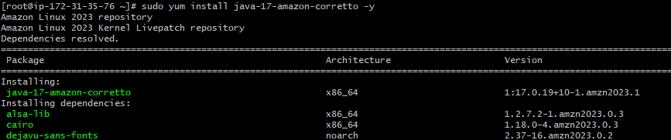
Install the packages & install jenkins
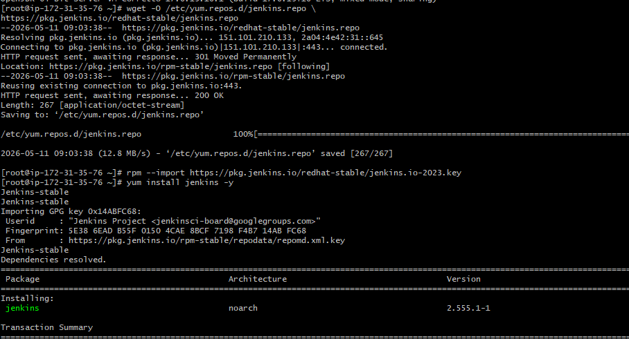

Change the port number (vi /usr/lib/systemd/system/jenkins.service)

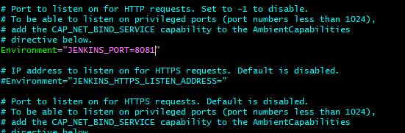
restart the service
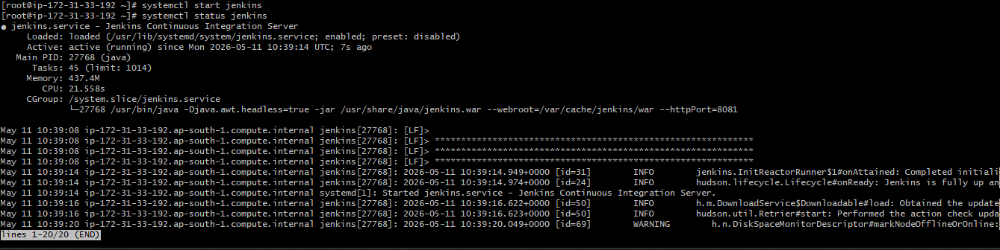
check in the browser by using http://<PUBLIC-IP>:8081
change the password to secure
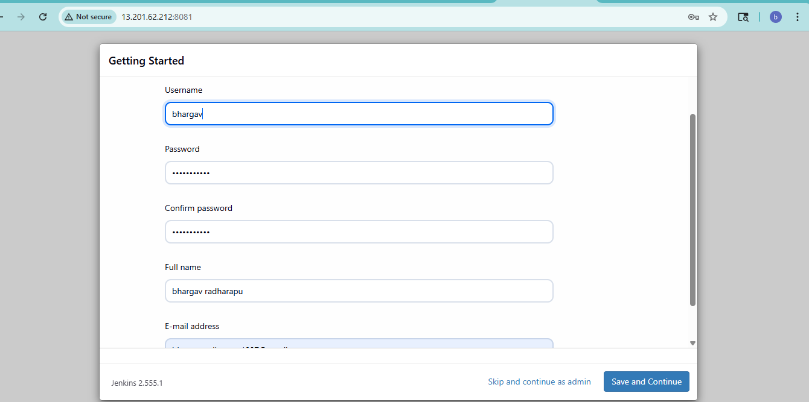

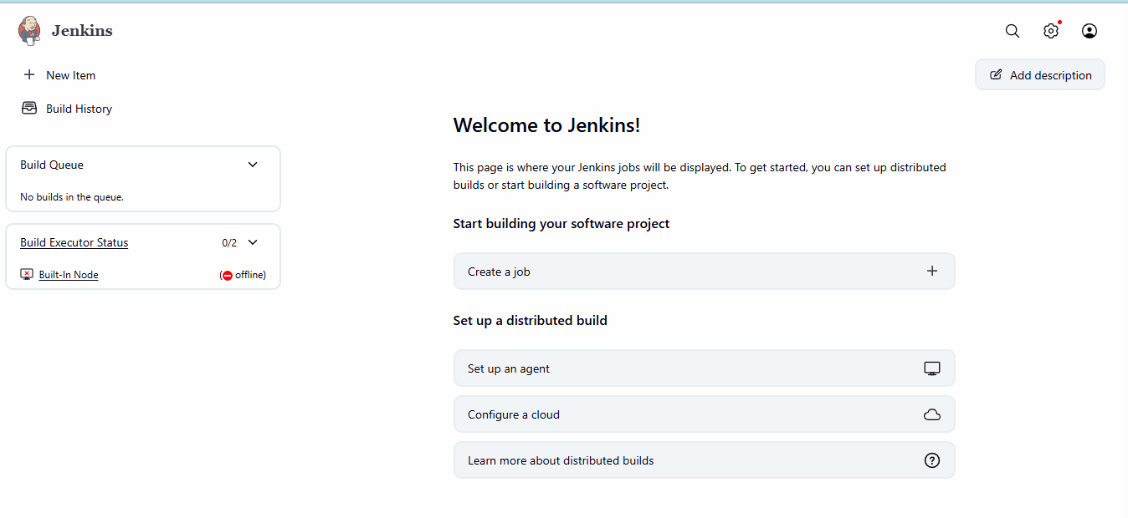

- Secure Jenkins server
Recommended Security Steps
Enable Authentication
Go to:
Manage Jenkins → Security
Enable:
- Jenkins own user database
- Logged-in users can do anything

Install Role-Based Authorization Plugin
Go to:
Manage Jenkins → Plugins
Install:
Role-based Authorization Strategy

Configure Role-Based Access
Go to:
Manage Jenkins → Security
Under Authorization choose:
Role-Based Strategy
Save.
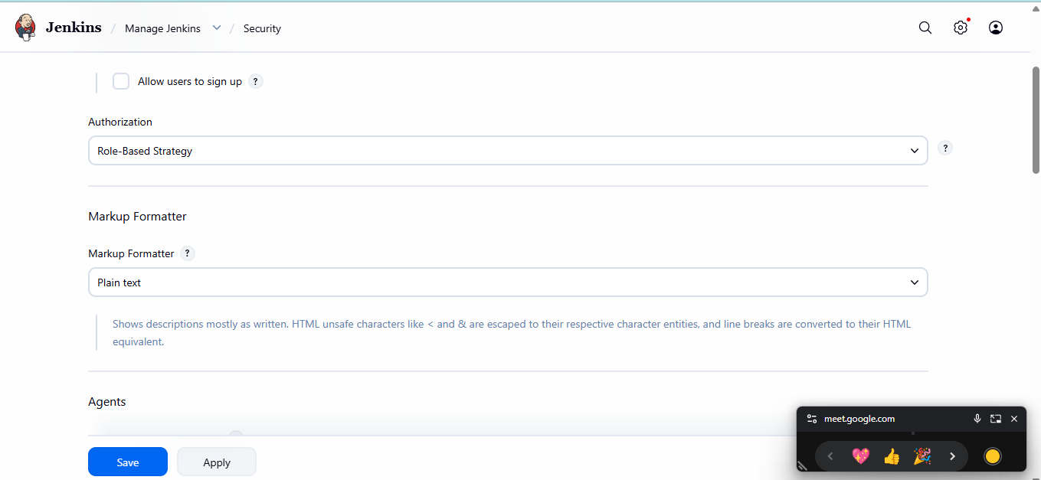

- Create users called DevOps, Testing in Jenkins with Limited access.
Create Users: DevOps and Testing:
Manage Jenkins → Manage Users → Create User
Give Limited Access
Go to:
Manage Jenkins → Manage and Assign Roles
Create Roles:
DevOps Role
Permissions:
- Overall Read
- Job Build
- Job Read
- Workspace

Testing Role
Permissions:
- Overall Read
- Job Read only

Assign Roles
Assign:
- DevOps → devops role
- Testing → testing role
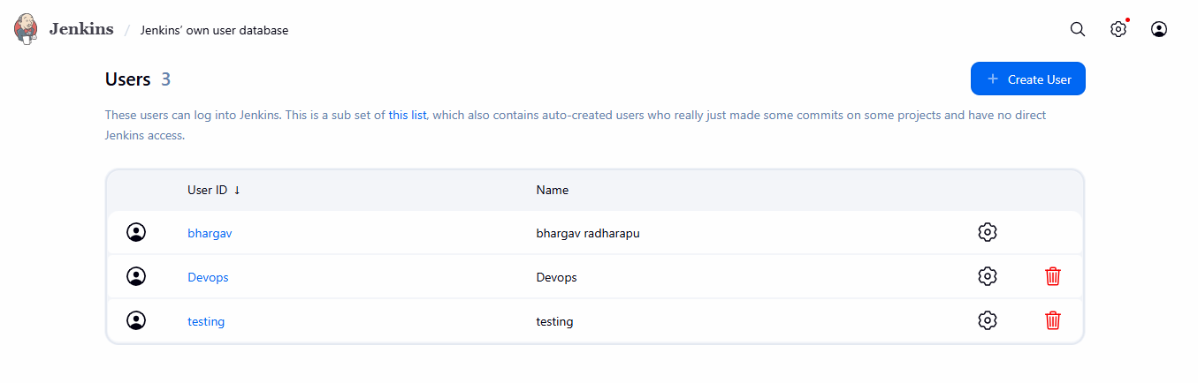
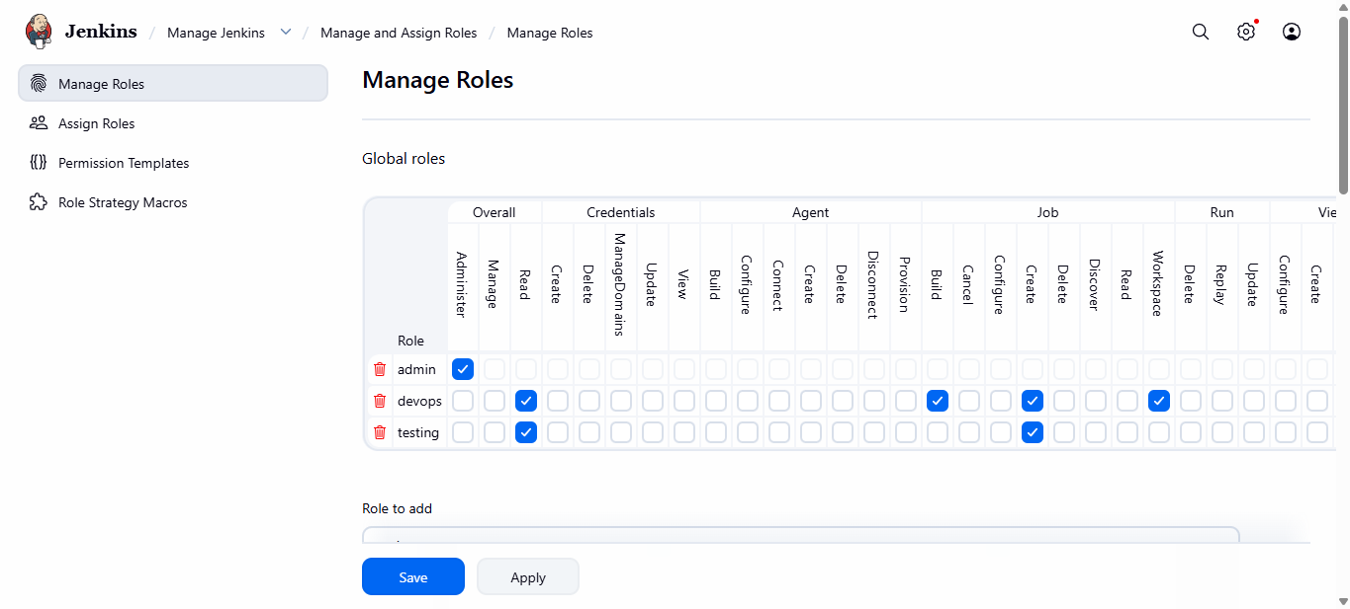

Check with the user credantials
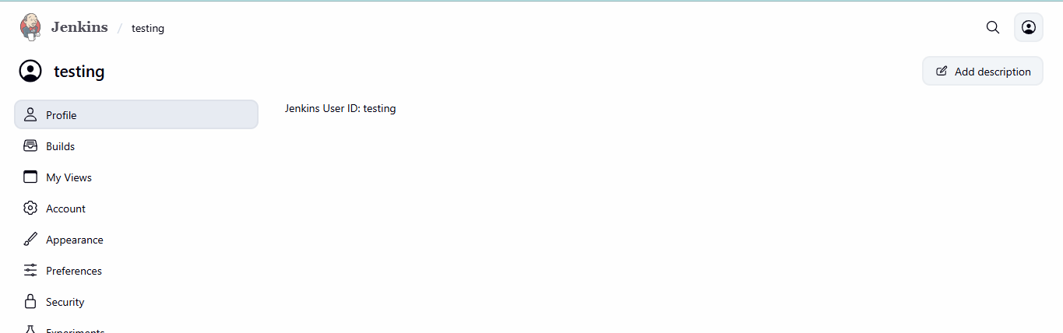
- Configure labels and restrict the jobs to execute based on label only.
Manage JenkinsNodesOpen Built-In NodeConfigure NodeAdd LabelsSave Configuration
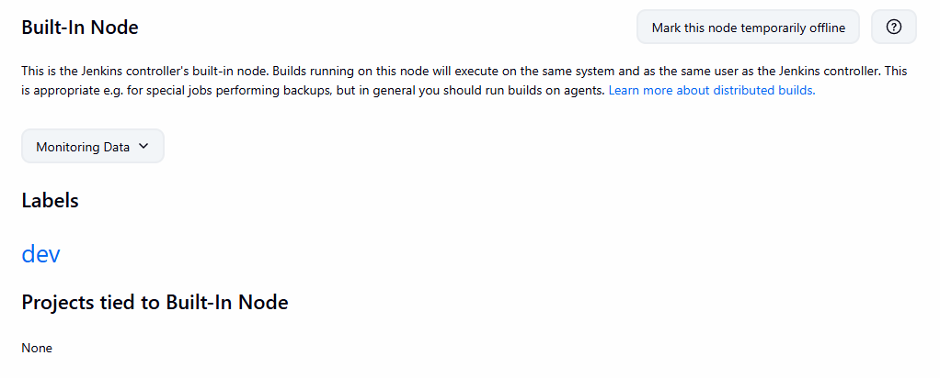
Create New Job
New ItemEnter name?Freestyle Project
Open Job ConfigurationEnable Label Restriction(Restrict where this project can be run) Add Label NameAdd Build StepSave Job
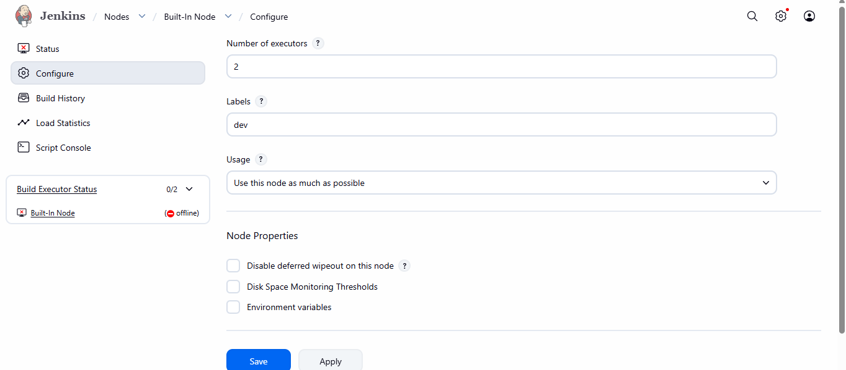
Build Job
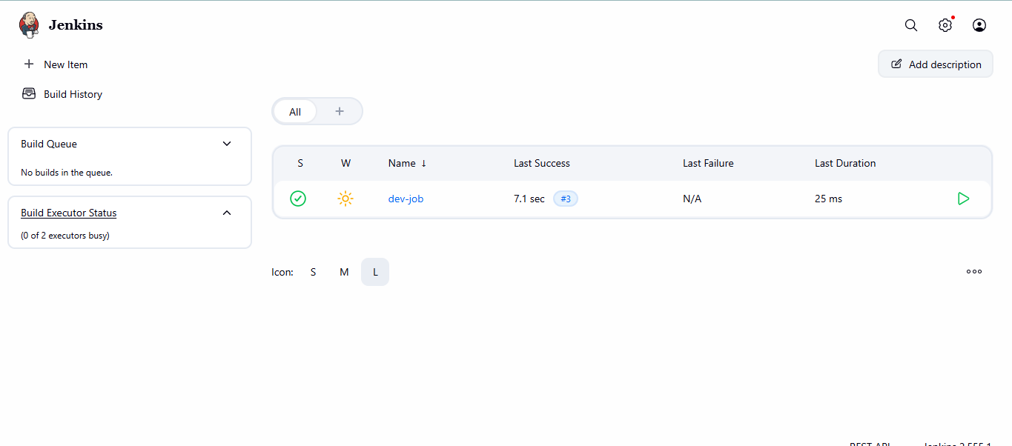

Verify Label Execution:
Build History → Console Output
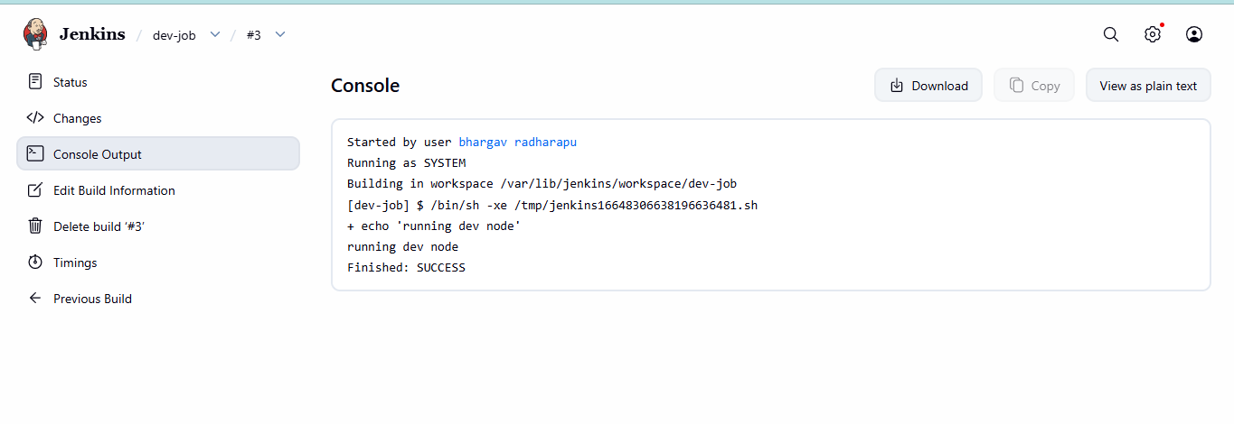

- Create Three sample jobs using the below URL.
  - Source Code:https://github.com/betawins/Techie_horizon_Login_app.git
Git installed on Jenkins server
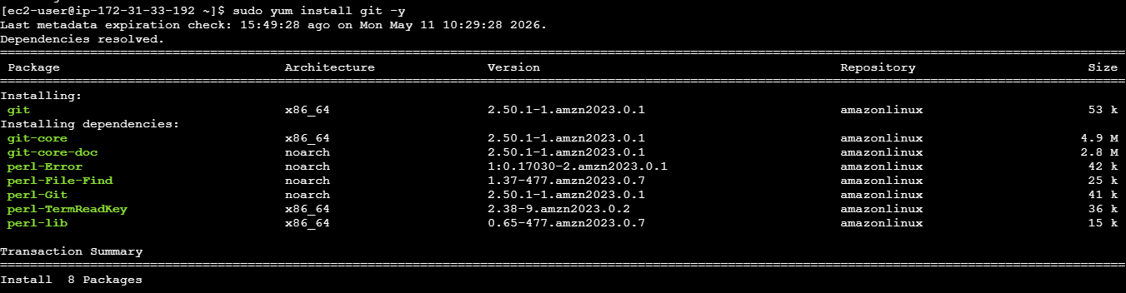
Install plugins
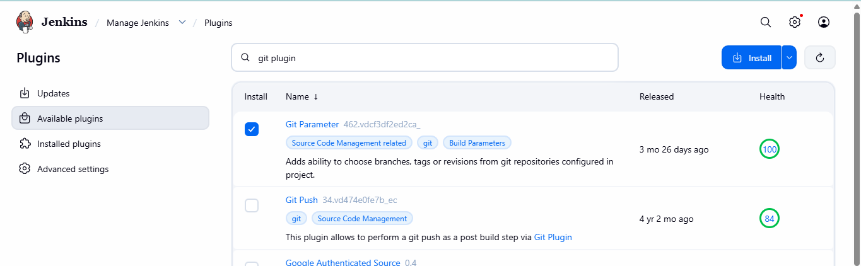

Create New JobConfigure Git RepositoryAdd Build StepSave JobRun Build Job
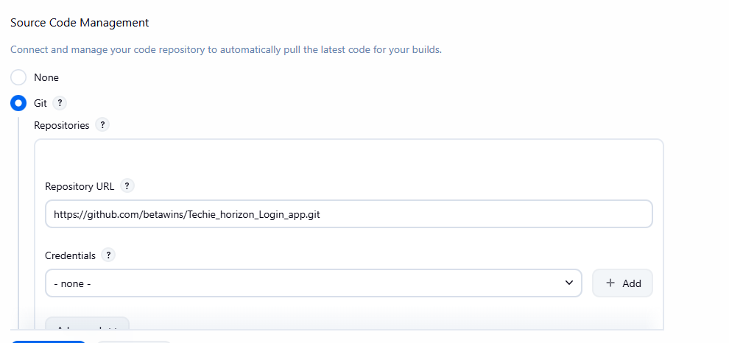
Verify Outputstatus
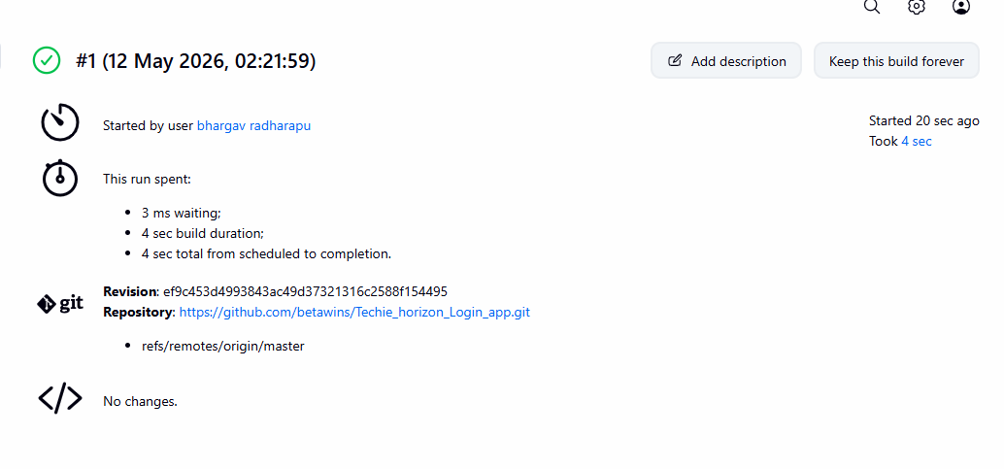

Console output
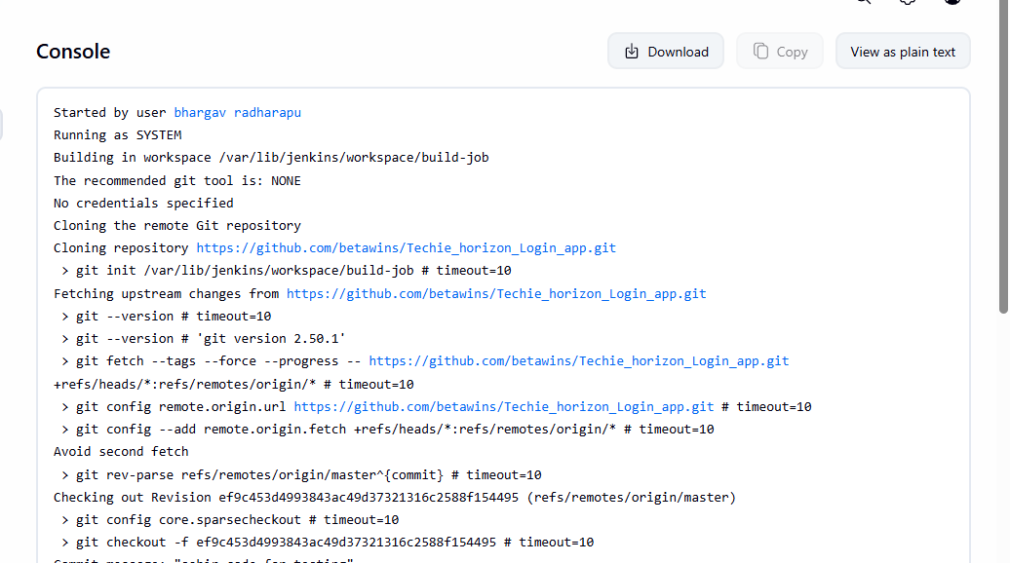
Create New Item(test-job) Configure GitRestrict Job to TEST LabelAdd Build StepSave and Build
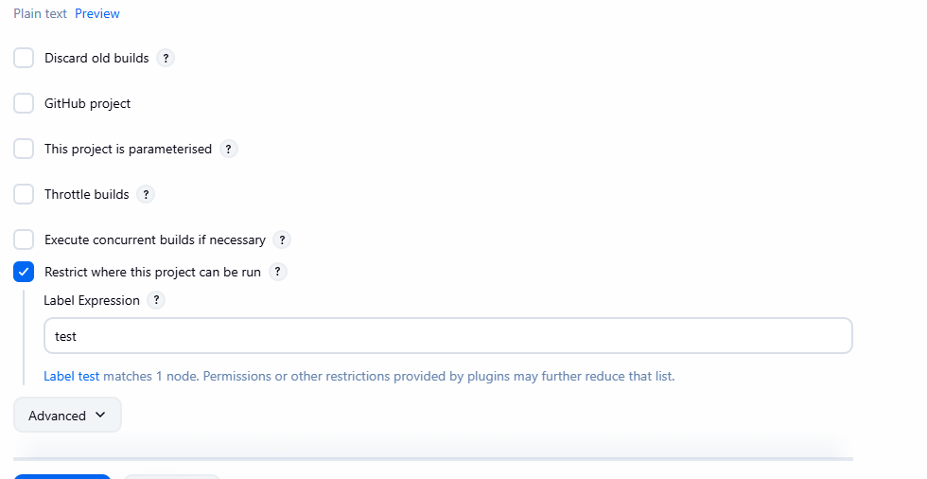

Check the status of job
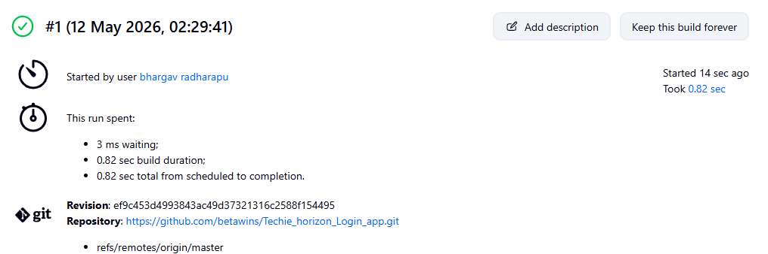
Verify console output
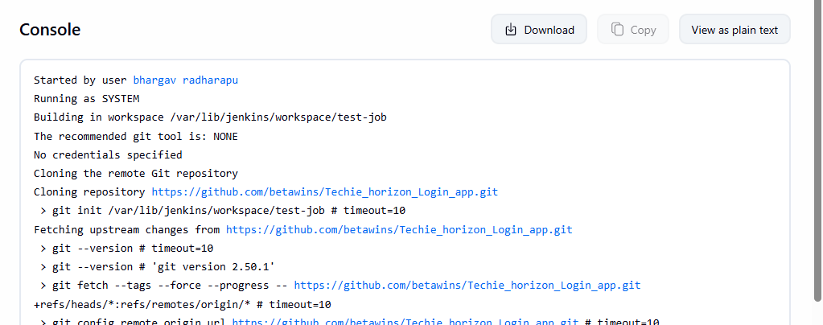
Create newitem(deployjob) Configure Git RepositoryRestrict Job to PROD LabelAdd Build StepSave and BuildVerify Console Output
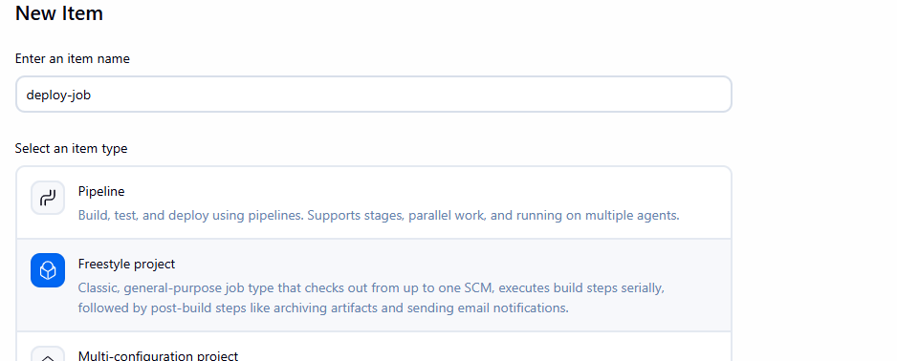

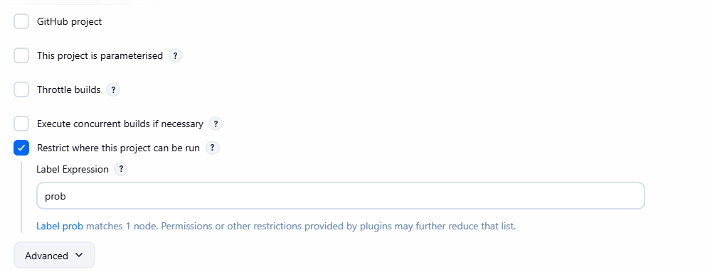

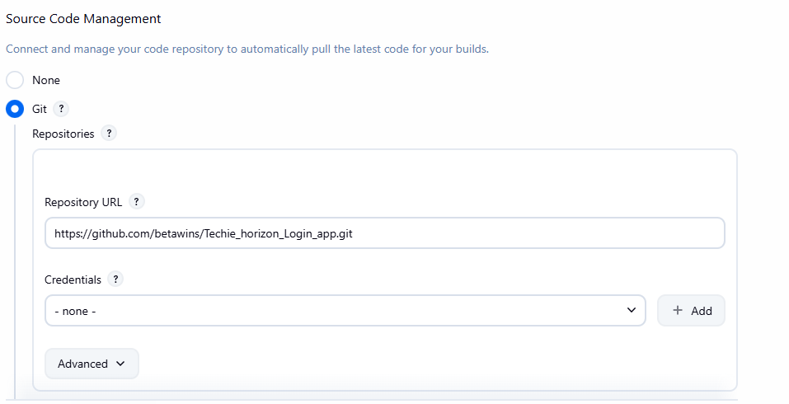

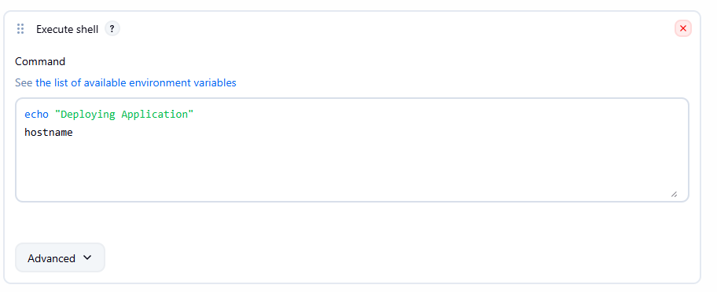

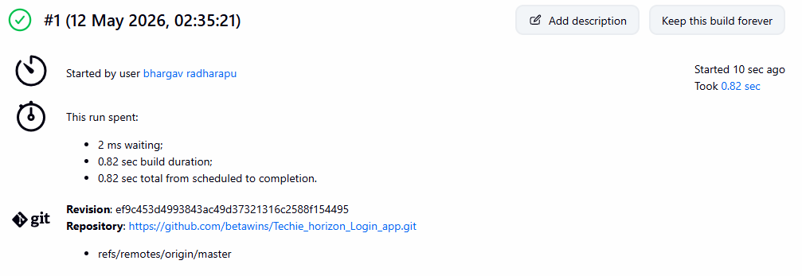

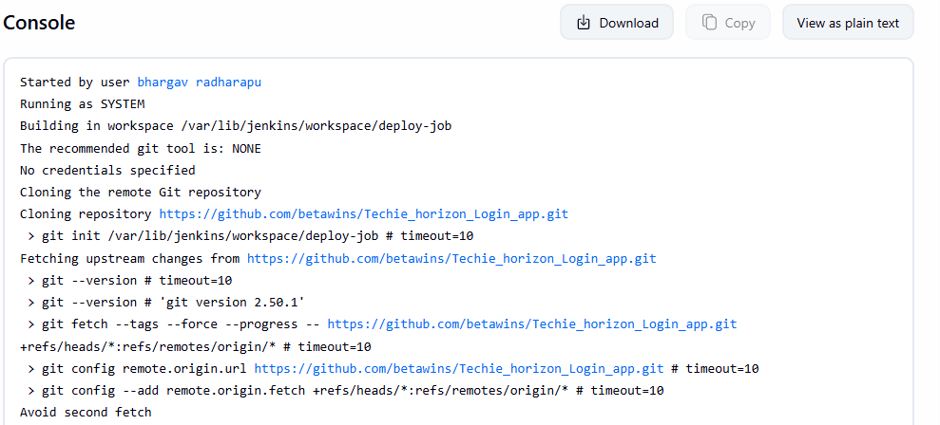

- Create one Jenkins job using GitHub Private repository.
Create a private repoOpen Token PageGenerate New Token(classic)
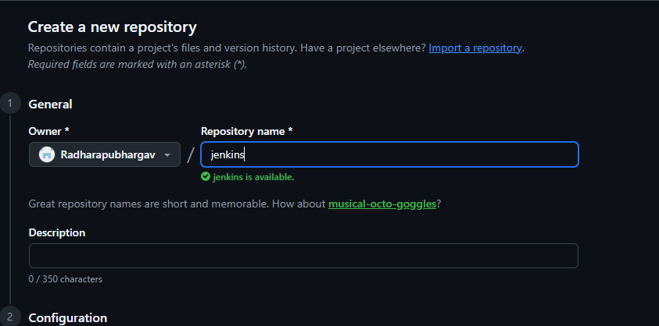
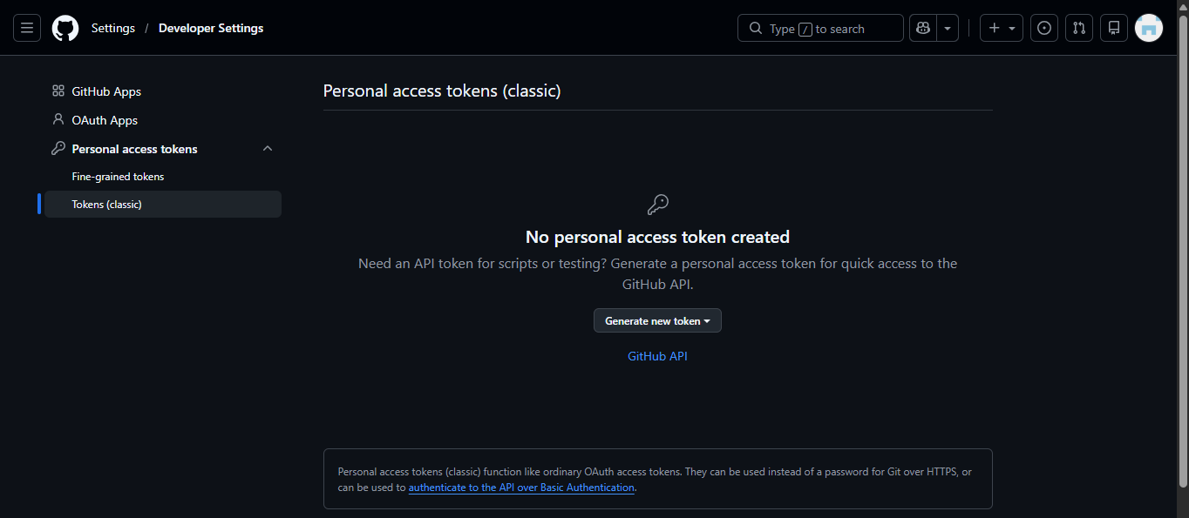

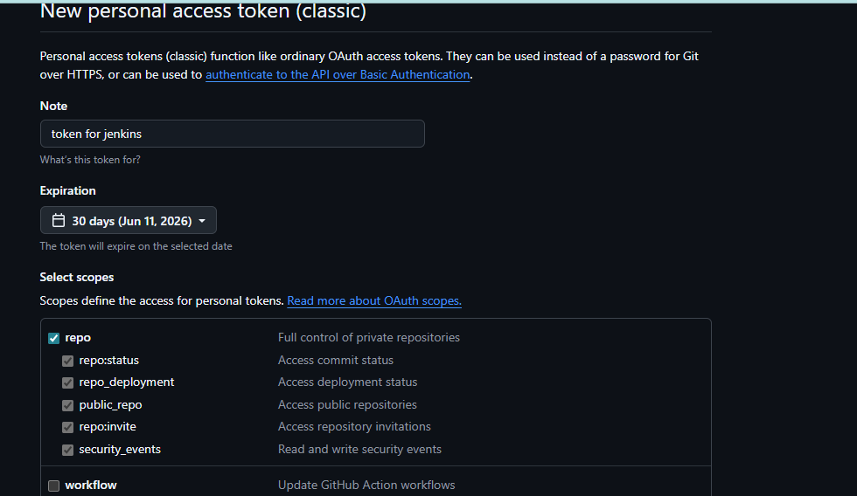
Configure token:
Manage Jenkins → CredentialsAdd CredentialsSave
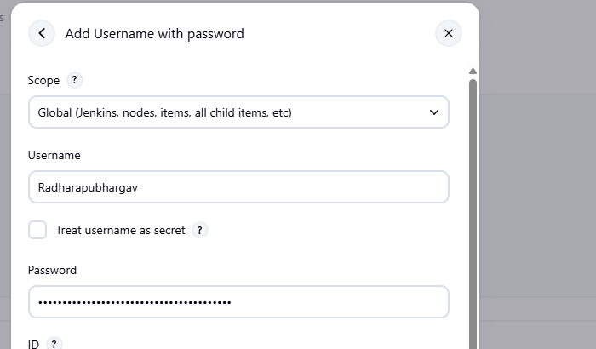

Create Jenkins Job for Private Repository:
Create New ItemConfigure Git RepositorySelect CredentialsAdd Build StepSave JobBuild JobVerify Build Success
